AI –
Artificial Intelligence (AI) aims to make computers "think" like humans enabling them capabilities to perform complex tasks such as gathering, problem-solving, adaptability and learning from experience.
AI splits into three different sections –

Narrow AI (Weak AI) – Specialized in specific tasks (like Alexa, Google assistant etc.). Another good example is Image Recognition applications which can identify individuals or aspects of an image.

General AI (AGI) – Hypothetical AI that possess the ability to understand, learn and apply Intelligence across a wide range of tasks typically done by humans. True AGI does not exist yet.

Super AI (ASI) – Hypothetical AI that surpasses human Intelligence in all aspects, capable of performing every intellectual task. This capability does not exist yet.

Machine Learning –
Machine Learning (ML) is a subfield of Artificial Intelligence (AI) that focuses on developing algorithms enabling machines to learn from data without explicit programming.
There are several methods in which algorithms can teach the systems such as –
- Supervised learning – AI developers train the model with labeled data (input and expected output). using this method, the model learns to understand the data and how it is associated with the correct output.
This method is useful for teaching models explicit tasks.
- Unsupervised learning – AI developers train the model without labeled data allowing the model to discover patterns and structures within the data.
This method is useful for teaching models tasks such as clustering, anomaly detection and association.
- Reinforcement learning – the model learns to interact with the environment and take actions based on rewards / penalties received from the environment with an end goal of maximizing the total rewards.
This method is very adaptive, and useful for sequential tasks.

Summarized, supervised learning aims to teach the model with user inputs while unsupervised learning gives the model free reign on how it decides to interact with the data, it lets the model create groups of similar characteristics and patterns while reinforcement learning is based on the idea of "if I do X I will receive a reward" and the goal is to receive as many rewards as possible.

Deep Learning –
Deep learning is the broader concept and field within "Machine Learning" that focuses on learning data through Neural Networks. It encompasses various methods and architectures designed to enable a system to learn from large amounts of data.
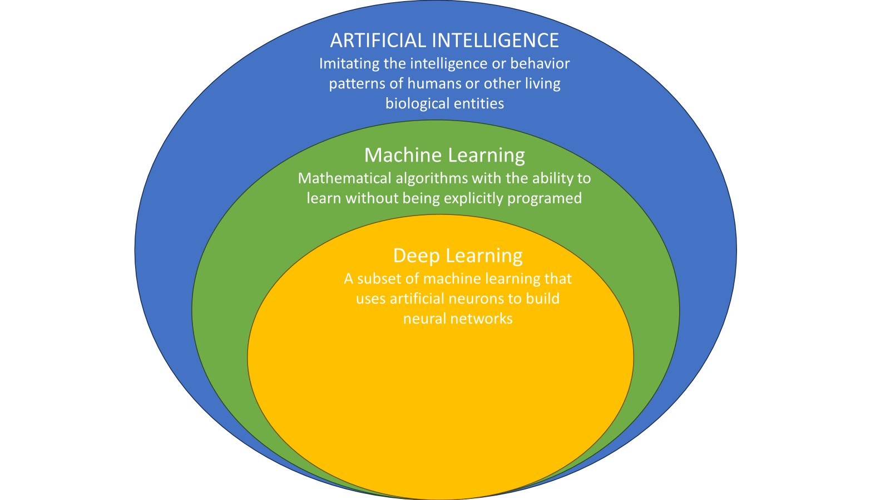

Within deep learning these are the underlying methods –
- ANN (Artificial Neural Network) – a model inspired by the human brain. It consists of interconnected layers of nodes ("Neurons")
It is a foundational, general term encompassing structure used for many specific architectures in deep learning, such as the "Transformer architecture" used for ChatGPT.

- RNN (Recurrent Neural Network) – a type of ANN designed for processing sequential data by maintaining a hidden state that captures information over time.
Tasks such as Language modelling, time-series prediction, and speech recognition utilize RNN models.
Example of an RNN is a "text predictor" on a phone, the phone automatically attempts to predict the next word in the sentence and the model learns through previous texts, overtime the model predicts much more efficiently.

- CNN (Convolutional Neural Network) – A type of ANN used for processing grid-like data such as images or videos using convolutional layers to detect spatial hierarchies of features.
Image classification, object detection and video analysis utilize CNN models.
A CNN can be used to identify cancer patterns in MRI images.

- Transformer – a type of ANN designed for sequence-to-sequence tasks; it works particularly well with NTP (Natural language processing) and uses self-attention mechanisms.

Neural Networks –
Neural Networks, inspired by the human brain, consist of interconnected layers of nodes that process and understand data by adjusting the connections between them.
Through a Neural Network a model can find complex patterns and learn from them.
A neuron has an input and an output. When it receives data, it computes a weighted sum of the inputs, adds a bias, applies a non-linear activation function, and sends the result forward to the next layer.
Layers -
- Input layer – receives the initial data.
- Hidden layers – Intermediate layers, processing and computing the data.
- Output layer – produces the result or prediction.

Learning process –
Weights and Biases – Connections between nodes (or neurons) have weights that determine the influence of one neuron over another. Each node also has a bias, which allows the model to adjust the activation function more flexibly. These parameters adjust during training to minimize the error in predictions. The weights capture the learned relationship between inputs and outputs enabling the network to make accurate predictions.

Activation functions –
Functions like ReLU or sigmoid introduce non-linearity and enables the network to learn complex patterns.

Gradient Descent –
Gradient descent is an algorithm used to minimize the loss function by iteratively adjusting weights and biases. Its 'testing' whether each weight should be increased or decreased to achieve a more accurate result.
The adjustments to the Neural Network are achieved through a mechanism called Backpropagation.

Training –
Forward propagation – Data passes through the network layers producing an output.
Loss function – measures the difference between the predicted output and the actual output.
Backpropagation – adjusts the weights and biases to minimize the loss function for more accurate results.
Using these training methods the model can create and evaluate relationships between data and create an accurate prediction for a more accurate result.

Example of Backpropagation & the Layers and their interconnectivity.
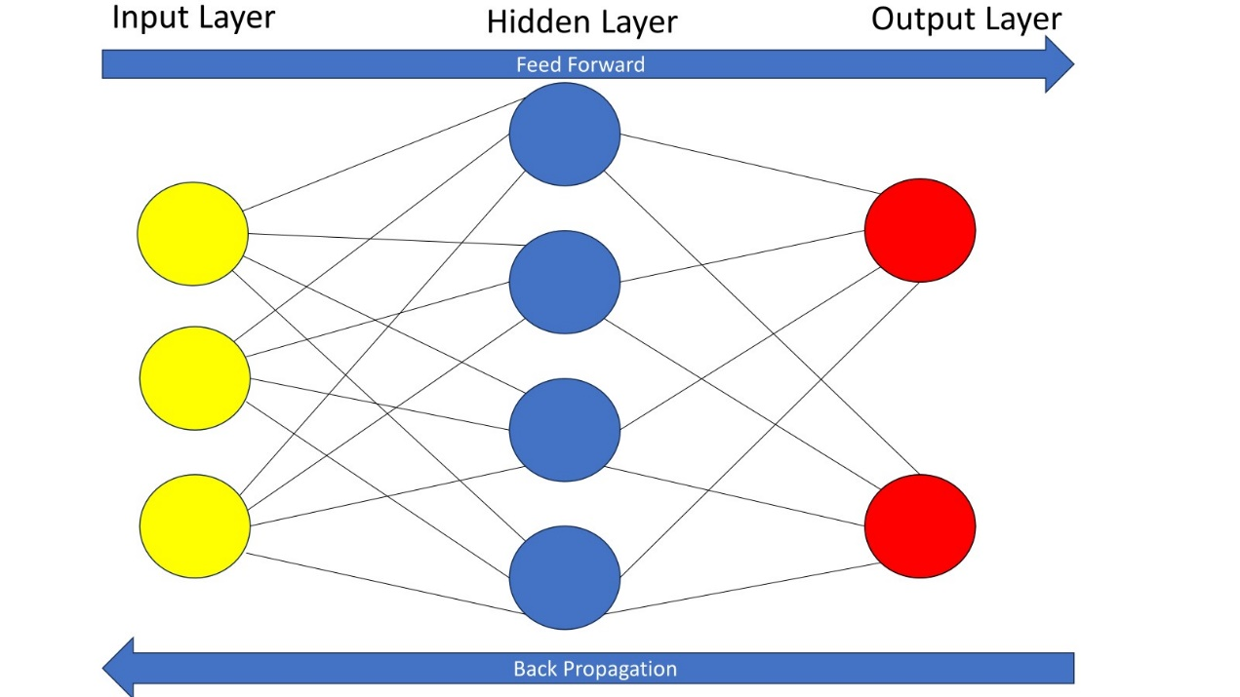

Summary –
Neural Networks learn by processing information through interconnected nodes in multiple layers. They adjust their parameters (Weights and Bias) based on the loss function through a process called Backpropagation using an algorithm called gradient descent to minimize errors and improve accuracy throughout training.

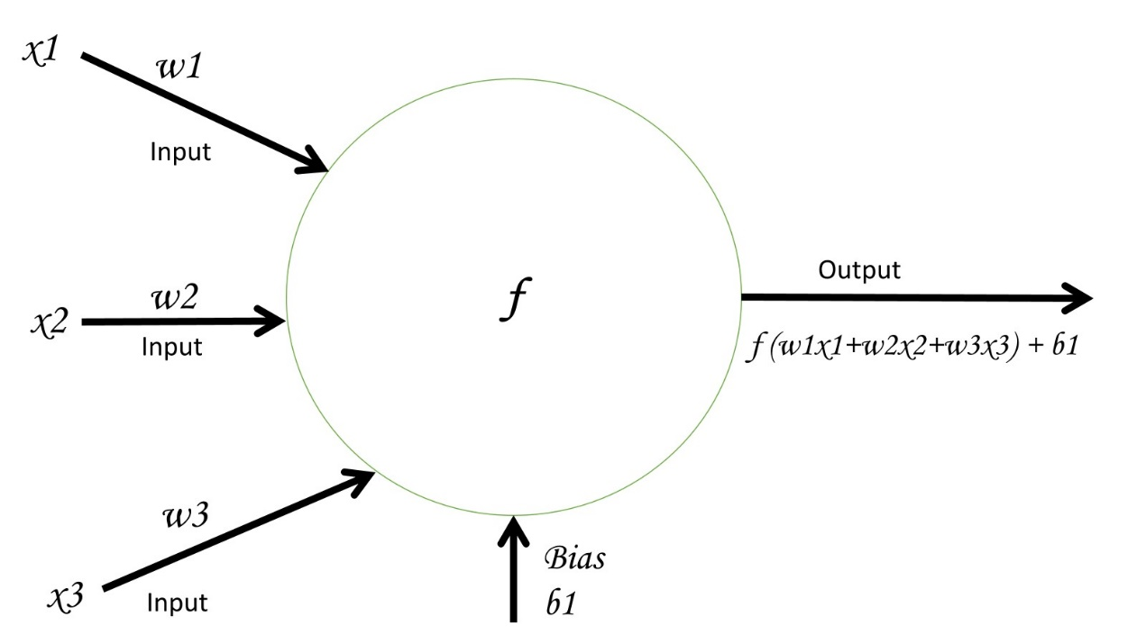
In the example above, assume that X-1, X-2, and X-3 are all different inputs of data coming from different nodes and F is the output layer.
Each input (X) reaches node F, node F calculates a weighted sum of each input with F's weight and adds a Bias.
This process is what happens at every node in the Neural Network, each Node has their own Weights and Bias independently from the rest of the nodes.
Inputs inherently have different values which is why the result is always different although the usage of the same Weight and Bias.

Neural Language Processing (NLP) –
NLP is a field in artificial Intelligence that focuses on enabling machines to understand, interpret, communicate, and generate human language.
NLP is useful for language translation, question-answering, and sentiment analysis (Opinion mining).
Models which aim to understand NLP utilize different methods to learn how to interact with human languages –
Text Processing
- Tokenization – breaking down text into different tokens (can include full words or even half words).
- Normalization – forcing all letters or sentences to a more uniform format (such as lowercasing or removing punctuation)
- Stemming and Lemmatization – Reducing words to their root forms (Walking -> Walk).
Syntax and Semantics
- Part-of-speech Tagging (POS) – identifying the grammatical parts speech in a sentence (The verbs, adjectives etc.)
- Named entity recognition (NER) – detecting and classification of entities in sentences (Names, ORGs, Locations etc.)
- Dependency Parsing – Analyze grammatical structure of sentence to understand the relationship between the words.

Through all these methods NLP achieves tasks such as language translation or more complicated sentiment analysis where context, semantics and syntax are crucial to understand a user's sentiment for a topic.

Computer Vision Concept –
Earlier we discussed how CNN type Neural Networks can process images and extract information, they do this through "Computer Vision" which is the field of a Machine Learning which aims to perceive and understand visual information from images or videos.

Object detection, Image classification and Image segmentation –
CNNs models can study a lot of images and eventually be able to identify objects in the image, surveillance systems or autonomous driving use these types of models.
The CNNs can later label and classify each object they detected for further analysis.
The CNNs can then segment the entire image and divide it into more meaningful segments to help a user understand the image a lot better.
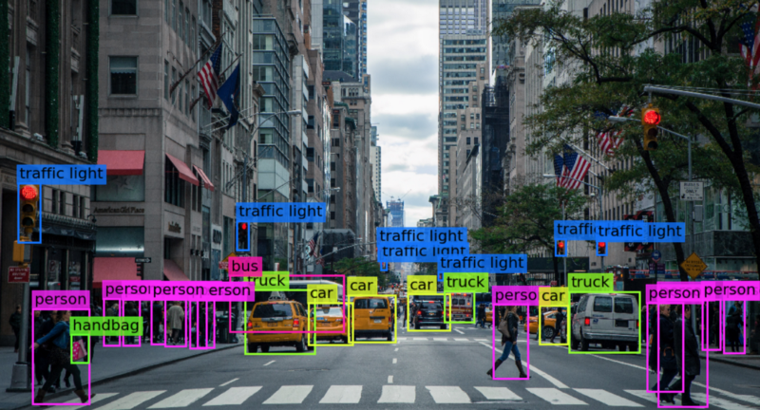

Data Mining –
The process of investigating large datasets to find patterns, correlations, and anomalies.
Data mining uses various Machine Learning techniques, including deep learning methods (both supervised and unsupervised), to discover these patterns.
Examples of data mining applications include market basket analysis, fraud detection, and customer segmentation.
Some techniques in Data mining are –
- Clustering – Clustering algorithms group similar data points together based on characteristics. Uses such as customer segmentation, anomaly detection and image segmentation.

- Classification – Classification algorithms assign predefined labels or categories to data instances based on their features. Uses such as spam filtering or sentiment analysis.

- Regression – Regression techniques predict continuous numerical values based on input variables. Uses such as prediction of stock market trends and housing prices.

- Association Rule Mining – ARM for short aims to discover relationships or patterns between large datasets. Uses such as association between frequently purchased together items.

A good example of this field is Cancer diagnosis, large datasets of CT scans are used to train a CNN model using a Neural Network.
The Neural Network learns to predict if cancer exists in the CT scans or not through patterns it recognized after going through these large training datasets.

Generative AI –
Generative AI refers to the concept of systems utilizing various techniques to create images, text, music and more. That differs from traditional AI which is used for analyzing data and interprets it.

What are Large Language Models –
Large Language Models (LLMs) is a type of AI model designed to understand and generate human language. LLMs are trained on large amounts of data and leverage advanced Neural Network architectures to process, understand and generate coherent, contextually relevant results.

Scale –
- Size – LLMs typically have billions or trillions of parameters (Weights & Biases).
- Data – LLMs are trained on large datasets that contain a wide variety of texts, books, articles, and other sources.

Training –
- Pre-training – LLMs are initially trained using unsupervised learning methods, the objective of this phase for the LLM is to predict the next word in a sentence, this phase teaches the LLM about grammar, facts about the world and some reasoning skills.
- Fine-tuning – after pre-training LLMs can be fine-tuned for specific tasks, if your LLM is used for creating short books then datasets related to this topic would be inputted to the LLM to improve it.

Architecture –
- Neural Networks – LLMs typically use a transformer type of architecture and use the self-attention mechanism.
- Self-attention – this mechanism allows the LLM to understand the importance of different words in the sentence and their relationship, this mechanism is useful for handling sequential data and long-range dependencies.

ChatGPT is a good example of an LLM model taught on large amount of data to provide numerous services.

High-Performance Computing (HPC) –
High-Performance Computing (HPC) refers to the use of supercomputers and parallel processing techniques to perform advanced computing tasks that require significant computational power, memory, and storage. Regular computers and systems are not on par with supercomputers and cannot manage the extreme tasks they face in datacenters today.

Components -
- Supercomputers - Machines capable of large-scale computing. These machines can be clustered together to form groups of supercomputers, working in unison to perform large calculations.
- Parallel Processing - The technique of spreading tasks into smaller sub-tasks across multiple processors, enhancing computational capabilities.
- High-speed Interconnects - HPC systems can utilize InfiniBand or other high-speed Ethernet technologies to enable rapid communication between nodes and minimize latency.
- Specialized hardware - HPC devices are inherently optimized as much as possible for performance, they are usually equipped with unique components such as accelerators (GPUs or FPGAs) to further boost performance for specific workloads.
- Optimized software - HPC applications are created to benefit the capabilities of HPC parallel processing resulting in much more efficient and reliable software.

** OpenMP as an example for HPC software utilizes the parallel processing of existing HPC infrastructure to enable developers to write code that can run on multi-core processors.

** GPU is a device that can run calculations across its many cores simultaneously, enabling parallel processing (Example – GH200 Grace Hopper).

** FPGA (Field programmable Gate Arrays) are configurable chips that can be programmed for specific tasks.

Applications -
- Scientific Research – Requires intense simulations and modeling (e.g., climate predictions).
- Engineering – Includes computational fluid dynamics and other complex engineering calculations.
- Financial Services – Utilized for risk assessment, algorithmic trading, and other math-intensive calculations.
- Medical Research – Involves tasks like genomic sequencing and drug discovery.
- ChatGPT & Generative AI require HPC for their computation.

Advantages -
- Speed - Significantly faster processing times.
- Scalability - Ability to manage larger data sets and more complex computations.
- Efficiency - Improved performance and energy efficiency for large-scale tasks.

Disadvantages -
- Cost - High initial investment for hardware and maintenance.
- Complexity - Requires specialized knowledge to set up and maintain.
- Software - Need for custom software optimized for parallel processing.

Fundamentals of Heterogenous Emergent and Quantum Computing –

Traditional Homogeneous Computing –
The traditional approach to computing involves homogeneous systems, where all processing units are identical. These systems execute tasks in a synchronized manner, with each processor performing similar functions. This uniformity simplifies system design and software development but can lead to inefficiencies, especially with complex, diverse workloads.

Heterogeneous Computing –
Heterogeneous computing, on the other hand, introduces the principle of task partitioning. This means breaking down complex tasks into smaller, more manageable sub-tasks and assigning them to specialized processing units best suited for each task. The goal is to optimize performance, efficiency, and processing time by leveraging the strengths of different types of processors.

Benefits of Heterogeneous Computing –
- Faster computing – By assigning tasks to the most appropriate processing units, heterogeneous computing can significantly reduce processing times. For example, offloading parallel tasks to GPUs can accelerate computations compared to using CPUs alone.

- Efficiency – Specialized processors are more efficient at their designated tasks, reducing energy consumption and improving overall system efficiency.

- Time Savings – Dividing complex tasks into smaller sub-tasks and processing them simultaneously leads to faster completion times, which is crucial for time-sensitive applications.

- Smarter System Design – Heterogeneous computing allows for a more intelligent allocation of resources, optimizing the use of available hardware and improving performance across various workloads.

Heterogenous computing is much more efficient, it can leverage the capability of different components in the system which best fit the task, it can intelligently partition tasks for faster performance and because it utilizes the strength of the different component it also saves power efficiently.

Emergent Computing –
The concept emphasizes the exploration and exploitation of a complex systems' emergent properties, unexpected behaviors and patterns that arise from interactions within intricate systems. This draws inspiration from natural phenomena, where simple rules and actions give rise to intricate and often unpredictable patterns and behaviors (example, "game of life").
In complex systems, individual components may follow basic rules, but their interactions can produce outcomes that are not easily predictable from the behavior of the individual parts. This phenomenon is observed in various domains such as biology (e.g., flocking behavior of birds), social sciences (e.g., market dynamics), and computer science (e.g., swarm Intelligence and distributed computing).
Understanding emergent properties is crucial in fields like high-performance computing (HPC), heterogeneous computing, and accelerated computing. In these areas, leveraging emergent behavior can optimize performance and efficiency by harnessing the collective behavior of diverse processing units and computational resources. For example, heterogeneous computing involves integrating different types of processors (CPUs, GPUs, FPGAs) to perform specialized tasks efficiently, leading to emergent performance benefits.
Exploring emergent properties in complex systems helps in designing more resilient, adaptive, and efficient solutions by anticipating and utilizing the unexpected yet advantageous patterns and behaviors that emerge from simple interactions.

Quantum Computing –
Quantum computing attempts to harness the principles of quantum mechanics to perform computations that are otherwise impossible with classical computers. At its core, quantum computers leverage the unique properties of quantum bits (qubits) to encode and process information in fundamentally unusual ways compared to classical bits.
Classical bits, which are binary (1s and 0s, representing electricity on/off), differ significantly from qubits. Qubits can exist in a state of "superposition," where they can represent both 0 and 1 simultaneously. This property allows quantum computers to represent and manipulate multiple pieces of information simultaneously, vastly increasing their computational power for certain tasks.
Additionally, qubits can exhibit "entanglement," a phenomenon where two qubits become correlated in such a way that the state of one instantly influences the state of the other, regardless of the distance between them. This interconnectedness enables highly efficient and complex computations that are infeasible for classical computers.
Quantum computing holds the potential to revolutionize fields such as cryptography, optimization, material science, and many others by solving problems that are currently intractable for classical computing methods.

Accelerated Computing –
Accelerated computing refers to the concept of enhancing computational performance beyond what traditional CPUs can achieve alone, it is done by using several methods such as parallel processing, specialized hardware, special software, and other accelerators (FPGAs, GPUs, specialized algorithms etc.).
The primary goal is to accelerate specific tasks and workloads and improve computational efficiency and reduce processing times for complex tasks.

Key components of Accelerated computing –
- DPUs – specialized processors designed and optimized to manage data-intensive tasks such as data compression, encryption, decryption, data analytics etc. they often incorporate specialized hardware reach their efficiency and thereby not versatile.
- GPUs – as discussed earlier, GPUs which are originally used for rendering graphics are extremely useful for parallel processing due to their ability to utilize all their cores simultaneously and break down complex tasks to smaller easier to do tasks.
- FPGAs – as discussed earlier, FPGAs are customized chips which can be programmed to the exact needs of the customer, they are implemented directly with the hardware and allow acceleration of specific tasks.
- ASICs – custom designed integrated circuits optimized for specific tasks, they provide incredible performance and energy efficiency but are not as flexible as FPGAs.
An example of an ASIC is Google's TPU (Tensor processing unit) which is remarkable at accelerating Machine Learning workloads.
Another example is VPUs which are specialized processors designed to accelerate vector and matrix operations (such as Intel's Movidius Myriad X used in drones for auto-flight).
There are many different types of ASICs each has their own specific usage for acceleration such as Neuromorphic computing for pattern recognition, Data processing engines used for data processing tasks such as database queries, graph analytics etc.
The need and driver for HPC and accelerated computing stems from the demand to process vast amounts of information in an era where there is so much information, conventional means falls short trying to work with the massive quantities of data.
The scientific community is a great example for the usage of HPC systems that incorporate accelerated computing, they use these systems to run complex calculations and pattern analysis aiming to predict weather patterns.
Although it has immense potential, it also brings a few issues, advanced computing presents issues such as hardware scalability, software optimization, algorithmic design, necessities such as electricity and cooling (water) and the footprint it leaves.

DMA, RDMA, GPUDirect and NVLink to Accelerate AI/ML –
To accelerate Artificial Intelligence (AI) and Machine Learning (ML) we can use several methods, each focusing on various aspects of system performance -
- Interconnect Acceleration – this concept refers to the technologies that allow for enormous amounts of data transfer between different components in the computing system, this is for reducing data transfer related bottlenecks and ensuring fast data movement which is essential for high performance AI and ML workloads.
- Compute acceleration – this concept (as discussed earlier) refers to the use of specialized hardware to speed up computational tasks (Hardware like mentioned earlier such as GPUs, FPGAs, ASICs etc.)

** TLDR – Interconnect acceleration makes data move faster and with less delay while Compute acceleration uses many GPUs (Or other specialized hardware) to do calculations in parallel.

DMA – DMA is a feature implemented on a specialized hardware component known as DMA controller, this controller can be a separate chip on the motherboard or integrated through other components such as the CPU, chipset, PCIe etc.
DMA allows different components in the system to directly talk with each other's memory without the need to go through a CPU during the data transfer process, instead these components communicate with the DMA controller which allows direct connection and manages the data transfer.
This reduces CPU overhead by off-loading data transfer tasks to a different component and allows the CPU to focus on other more complex tasks, these DMA controllers are usually more efficient and improve overall system performance.

RDMA – RDMA is a feature designed to improve DMA by enabling direct memory access across a network allowing components in different systems across the network to share memory as if they were on the same machine.
Example – Two GPUs in different systems or even geographical locations can share memory and communicate directly using RDMA (that come in a NIC form) enabling efficient data transfer and low overhead on the CPU on both systems.
These RDMA use different protocols such as InfiniBand and RoCE.

GPUDirect (Nvidia technology) –
Nvidia's solution to DMA & RDMA comes in GPUDirect technology, it achieves GPU-to-GPU memory sharing across a network on Nvidia GPUs.
Due to it being tailored to Nvidia's product it could be more optimized compared to other RDMA / DMA cards.
The main difference between regular RDMA / DMA cards and GPUDirect is their existence, While RDMA & DMA usually come as a physical component which is implemented in the server GPUDirect is a software and set of drivers which can be installed on every GPU & NIC that supports it thus allowing for more room in the server and PCIe links and less hardware failure bottlenecks.
GPUDirect is supported by various Nvidia products such as Tesla, Quadro, GeForce GPUs and Mellanox network adapters while also compatible with many operating systems such as windows, Linux, and VMWare.
These features also require CUDA or other APIs that support GPUDirect P2P and GPUDirectRDMA.

NVLink –
So far, we have discussed about how we can ignore the CPU to allow for faster data transfer while lowering CPU overhead but to allow this through GPUDirect.
This brings us to the next "Bottleneck" which is the PCIe connection that is limiting our GPU-to-GPU communication or even GPU-to-CPU, these PCIe slots are limited with the amount of data they can transfer so to avoid this bottleneck Nvidia offers NVLink bus protocol.
This bus protocol significantly improves data transfers between different components in the system compared to PCIe bus protocol, it offers higher bandwidth, more links and lower latency.
Both NVLink and GPUDirect and Nvidia proprietary protocols.
NVSwitch –
Nvidia created both NVLink and GPUDirect to accommodate the increase of GPUs in the datacenter and the need to have them communicating together, this alone presents several challenges such as scalability, latency etc.
To answer these challenges Nvidia created NVSwitch.
NVSwitch is an advanced switch architecture to allow for scalability and high bandwidth with low latency communication between GPU-to-GPU and GPU-to-NIC.
NVSwitch allows for up to 16 GPUs in a single system to seamlessly communicate with each other to allow for parallel task executions and HPC.
A good example of that would be Nvidia's GDX2 which is a HPC machine capable of delivering fast and efficient computing for workloads such as AI deep learning.
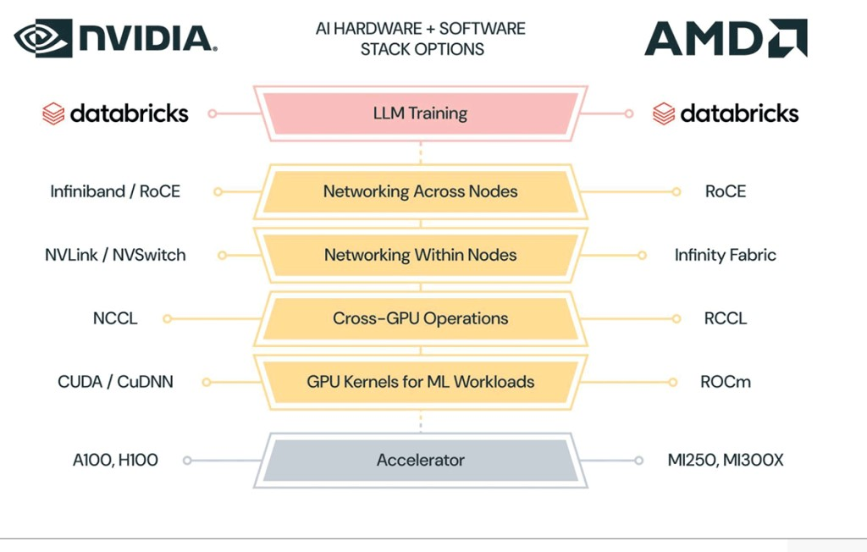
Creating and Training a Large Language Model (LLM) for a Chatbot Application
HPC AI/ML Networking –
In HPC Enviorments low latency, high availability and zero tolerance packet loss is crucial for AI/ML jobs.
Ensuring such stringet networking requirements involves discussing various protocols and techniques.
These topics must align with future HPC AI/ML demands such as increasing scalability, high availaiblity and ability to handle large data processing.

InfiniBand –
In general InfiniBand is a networking technology widely used in HPC and AI/ML environments to ensure high-speed, high-availability, scaleable and low-latency communication.

- Switches – devices that connect nodes (servers) to facilitate communication (example - Quantum-X800).

- Cables – high performance copper or fiber optics cables designed to withstand high speed data with minimal signal loss (example – Mellanox LinkX DAC cables).

- Network Adapaters – Host channel Adapters (HCAs / NICs) that connect nodes to InfiniBand networks.

- Software – InfiniBand offers management software for configuring, monitoring and optimizing the InfiniBand network (example – MLNXSM for subnet managing).

InfiniBand introduces different protocols too such as Subnet Manager (SM) and Subnet Administraton (SA) to achieve capabilities similar to STP or Vlans or even LACP like protocol called Automatic Path Migration (APM).

InfiniBand is another network architecture / protocol suite just like how Ethernet uses it's own protocols and architectures.

Together these technologies together enable GPU-to-GPU (RDMA / GPUDirect) communication and ensure low packet loss and high speeds in the ever increasing HPC environments.

RoCEv1 & RoCEv2 –
RDMA over Converged Ethernet (RoCE) is a protocol introduced in 2010 to allow RDMA over Ethernet based networks.
In 2014 RoCEv2 was released which improved upon the already existing protocol.
Allowing RDMA over Ethernet based networks allows for flexibility, cost-effectiveness, and makes low latency and high performance communication more accessible.
Differences between version 1 and 2

 | RoCEv1 | RoCEv2
Layer | Layer 2 | Layer 3
Routing | 1 Broadcast Domain | Routeable
Latency | Lower | Higher
Flexibility | Not flexible | flexible

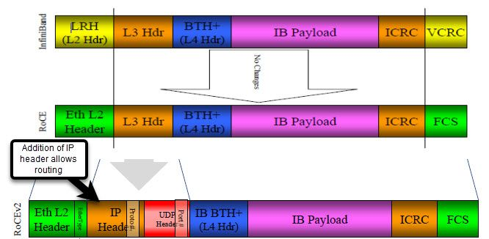
InfiniBand packet versus RoCEv1 and RoCEv2 packets.

As you can see the Ethernet packet with RoCEv2 protocol is very similar to the InfiniBand packet, the main difference is the addition of IP header which allows routing (ip source & ip destination).

In addition to this, RoCE is also supported by several other networking protocols such as ECN and PFC, these protocols.
ECN – Layer 3 Ethernet based feature, needs to be enabled on both endpoints (Switch to RDMA capable NICs for example). It is capable to detect and alert congestion.
This feature allows the switch / router to mark packets with ECN bits during a network congestion. The destination endpoint receives the marked packet and alerts the source endpoint to adjust their transmission rate.
PFC – Layer 2 Ethernet based extention of IEEE 802.1Qbb protocol, it is used to ensure priority of packets during congestion.
The protocol divides traffic into different classes and during a congestion it gives priority to specific classes.

Data Center Quantized Congestion Notification (DCQCN) –
Joint effort of PFC and ECN for Datacenter environments ensuring sufficient end-to-end congestion management and reducing packet loss.
DCQCN is a rate based and feedback based congestion control protocol.
Mechanism of DCQCN –
Quantized Feedback – DCQCN supported devices constantly monitor the network for congestion, once they spot a congestion they send a Quantized Feedback message to both endpoints.
Both endpoints will adjust their transmission accordingly.

Feature | ECN | PFC | DCQCN
Layer | Layer 3 | Layer 2 | Layer 2/3
Congestion  Detection | Routers &  Switches | Primarly  Switches | Routers &  Switches
Feedback  Mechanism | ECM  Marking | Pause  Frames | Quantized  Feedback
Target Use | General IP  Networks | Ethernet  Networks | RoCEv2
Lossless  Transmission | No | Yes | Yes
Traffic  Prioritization | No | Yes | Yes
Precision  Control | Basic | Basic | High  Percision

A table showcasing the advantages of each protocol / feature and their capabilites.
Overall DCQCN is primarly the protocol used in Ethernet HPC enviorments due to it's robust nature and lossless transmission capabilties.

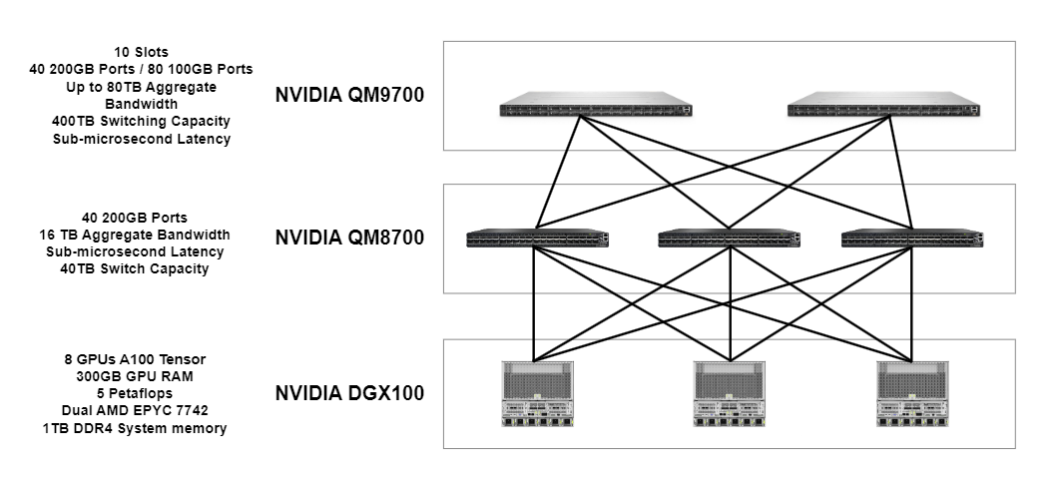
This network is an example of a Leaf and Spine topology with InfiniBand equipment.
This example can also use Ethernet based techologies like the Nexus 9k and allow parallel computing through RoCEv2, This can be managed through Cisco's "Cisco Nexus Dashboard Fabric Controller".
The main difference between InfiniBand and other Ethernet based fabrics is InfiniBand's SHARP mechanism

Scalable Hierarchcial Aggregation and Reduction Protocol (SHARP) –

Technology developed by Mellanox (now part of Nvidia) aimed to improve the efficiency of data processing in HPC and AI enviroments.
SHARP is a Mellanox proprietary protocol.
SHARP allows network devices (such as switches or routers) to perform certain types of processing, specifcially reduction of operations.
SHARP can work on both Ethernet technologies and InfiniBand technologies.
SHARP's capabilities allow for offloading unncessery workloads from the nodes and doing them inside the network, this in turn gives the nodes more time to focus on more important compute tasks.

The key points of SHARP –
- Network Processing – offloading specific computational tasks (reduction operations such as summing, averaging or other aggregations) to the network hardware.

- Hierarchical Aggregation – SHARP hierchy is built to allow for aggregation at various points within the network, this further optimizes the data flow and processing efficieny.

Benefits of SHARP –
- Reduced Latency – achieved by enabling network devices to directly process and compute AI/ML workloads. This minimizies the need for data to travel between nodes for computation which significantly reduces latency.

- Improved throughput – achieve through nodes offloading certain computational tasks to the network, this allows the nodes to focus on more critical tasks enhancing the overall efficiency and performance.

- CPU Offloading – network devices perform reduction operations within the network allowing CPUs to handle more important tasks.

- Efficient Resource Utilization – switches and routers can perform computation and processing for AI/ML workloads in addition to basic switching and routing tasks leading to a more balanced system performance and better resource utilizaiton.

White Box Switches –
In the realm of ever-changing technologies and networking the infrastructure is continuing to evolve, innovations in efficiency, flexibility and cost-effectiveness lead to new technologies and open-source networking operating systems (NOS).
These NOS technologies are challenging tradinional OEM switches and proprietry software solutions, why need a cisco switch if you can buy a cheaper, faster and more reliable NOS?
White boxes or unbranded switches represent a diviation from traditionalOEM switches (Cisco, HP, Juniper etc.).
Unbranded switches usually refer to ODM constructed devices (the physical hardware before it reaches Cisco for implementaion of software for example).
White Boxes and Unbranded switches are devoid of any predetermined operating system, instead the user can install their perferred NOS.

Advantages of White boxes and Unbranded Switches –
- Flexibility – the end user can install the most fitting NOS onto their devices.
- Cost-effectiveness – a White box is usually cheaper and a NOS can be open-source and free.
- Control – a user can have complete control over their device and the settings of it unlike some properitry devices.

White boxes and Unbranded switches usually feature sillicon chips from manufacturers such as Marvell, Intel, Mellanox, Cisco or broadcom which enable high performance for fraction of the cost.

SONiC –
SONiC is an open source NOS developed by microsoft and contributed to the OCP community.
SONiC designed for creation of scalable and manageable network solutions in large-scale datacenters.
SONiC uses a moduler architecture allowing for flexiblity and modularity

- Switch State Service (SWSS) – Manges switch states and configurations
- Switch Abstraction Interface (SAI) – Provides a standaraztion API for hardware abstraction, enabling SONiC to run on different hardware platforms
- Orchagent – Orchestrates various network services and applies configurations to the hardware

SONiC NOS is feature-rich with capabilites allowing for flexibility, scalability, containerized microservices and is community-driven by major companies such as MSFT, Alibaba, DELL and others.
Another example of a NOS can be Cumulus Linux which is also flexible, based on linux and is compatible with a variety of hardware, it has full support for layer 2 and 3 and allow for automation and scripting.
Big Switch Networks (Big Switch Light) is another prominent NOS.

HPC AI/ML Storage –
As artificial Intelligence (AI) continues to grow so does the need for an advanced surrounding environment to keep up with its progress.
We previously discussed about how networking has improved to facilitate AI/ML growth, now we will discuss about storage demands in the ever increasing AI/ML world.
AI models (such as LLMs, K-Means, CNNs etc.) require vast amounts of data for training. This data needs to be stored efficiently and accessed quickly.
The growing demand for rapid efficient data access has led to the development of new storage systems and techniques.

Hard Disk Drives (HDD) – the first step in improvement of Hard disk technology, the mechanical nature of HDDs posed as a significant bottleneck. The moving read/write heads created latency issues hindering the performance of AI applications.

Solid-state drive (SSD) – the introduction of SSDs marked another significant leap in storage history, They use non-volitile NAND flash memory, which retains data without power. They offer higher storage density and fast read and write operations.
SSD initally used ACHI protocol over SATA cables to run a single queue data path which is considerably slower compared to today.

Although storage technology has progressively advanced, it still doesn't meet the requirements of today's storage needs for HPC AI/ML workloads.

To meet the demanding requirements of AI infrastructure several specialized technolgiees have emerged –

- Non-Volatile Memory Express (NVMe) – NVMe is both a protocol and sometimes refered as a type of hardware device that provides increased throughput and faster read/write speeds compared to older technologies such as SATA SSDs.

NVMe protocol provides faster read/write speeds and throughput and increased queues and paths for data transfer.

SSDs using NVMe technology are connected to the system through M.2 or PCIe leveraging the NVMe technology (or older SSDs use SATA) for data transfer.

- Persistent Memory (PMEM) – PMEM combines the capabilities of DRAM (Dynamic Random Access Memory) and NAND flash memory, offering both speed and persistence.

PMEM provides the fast access and low latency of DRAM, which is used for system memory, while also retaining data like NAND flash memory even when power is lost.

This makes PMEM an ideal solution for faster, persistent storage, especially beneficial for AI applications where both high-speed access and data persistence are crucial.

- Disaggregated Storage – a concept involving the seperation of compute resources (CPUs, GPUs etc.) from storage resoureces (SSDs, HDDs etc.)

The physical and logical seperation of these components allows for better scalability and flexibilty in the network.

- Cloud Storage – provides better scalability and higher latency.
What is High Performance Storage? –
High Performance Storage (HPS) refers to a category of data storage solutions designed to meet the demands of AI/ML workloads.
It includes demands such as –
- Fast transfer rates
- Low latency
- High scalability
- Reliability
HPS type storage system should be able to withstand and maximize performance in an AI/ML environment which requires rapid access to data and analysis of large datasets.
The importance of HPS cannot be overstated. As AI models become increasingly mode demanding and complex the data to train and inference grows exponentially.
HPS systems ensure the data can be stored, accessed and processed without creating bottlenecks.

TLDR; Faster data transfer and high-density storage systems with improved efficiency are essential for training and inferring large AI models.

There are several components and features of High performance storage systems which distinguish them from traditional storage systems –

- Scalability – it's essential that high performance storage systems can scale efficiently due to the nature of AI/ML workloads.
Capacity Expension – the ability to increase the capacity to accomedate Petabytes of data, seamlessly adding storage nodes without distruption
Performance Scaling – enhancing storage devices perfomance to increase IOPs (Input/Output Operations per second).
Incorperating both performance and capacity scaling ensures AI applications have enough room to store growing volumes of data and can access and process this data swiftly.

- High data Transfer Rates – in HPS enviroments high data transfer rates are crucial.

Bandwidth – the system's read/write operations are mesured in GB/s.
HPS requires devices capable of high speed read/write capabilities to process more data in less time.

- Latency – HPS devices must ensure that data is acc essed with minimal delay. Low latency significantly speed up AI/ML workloads, especially in the inference phase.

For example, when training AI models latency, capacity and processing speed all contribute to the efficiency of how quickly the model can learn and infer.

Parallel Processing Capabilities –
Parallel processing in high performance storage (HPS) systems in critical for optimizing AI workflows, these capabilities allow storage systems to process, retrieve and store information more efficiently and quickly compared traditional storage systems.
HPS systems designed for parallel processing typically incorporate features such as –
- Multiple Input/Output paths that allow data to be read and written concurrently, reducing bottlenecks in dataflow
- Advanced algorithms for data distribution and balance, ensuring all processors or cores are participating in increasing efficiency.
- Support for distributed file systems that enable data to be stored in multiple nodes which can be accessed parallely.
- Integration with high speed networking technologies such as InfiniBand or ethernet fabrics supporting high bandwidth and low latency.
Example of these capabilites –
Parallel processing in HPS systems enable differernt stages of an AI pipeline to be executed cocnurrently.
While one part of the system is working on feeding data to the model another part can be engaged in running validation tasks etc.
This kind of multitasking ultimately lead to increased performance and higher workload speeds.

Reliability and Durability –
Other imporant aspects of HPS include phyiscal and logical redundancy of HPS devices, incorperating failover mechanisms, advanced error correction algorithms, snapshop technologies and data replication, regular testing and quality of service controls.

Advanced data Management features –
The sophistication of HPS is not only evident in the speed and scalabilty but also in the management of it.
We'll talk about three critcal data management capabilities in High performance storage –

- Automated tiering – A concept in high performance storage systems where data is intelligently categorised into three different groups based on the frequency of their usage.

Hot Data – frequently accessed data is categorised as "hot" and stored on the fastest storage devices, such as NVMe SSDs.

Warm Data – data accessed less frequently but still regulary is categorized as "warm" and stored on moderately fast storage devices, such as SATA SSDS.

Cold Data – Infrequently accessed data is categorized as "cold" and is stored on slower, high-capacity storage devices such as, traditional HDDs.

This approach ensures frequently used data is quickly accessible, optimizing the overall performance and efficiency of the storage system.

- Snapshots – an essential feature in HPS systems, capturing the exact state of a storage system at a specific time.

They're particularly crucial in AI environments where agility to recover from data mishaps without reverting to full backups can be a game-changer.

- Replication – a critical process in HPS ensuring data durability and accessability by creating redundant copies across diverese locations.

By replicating important data and storing it across different storage systems or even locations you can guarantee the safety of the data incase of an emergency.

Understanding AI/ML Storage workloads and it's characteristics –
We can differentiate between traditional storage workloads and AI/ML due to their various distinct characteristics.

- Data Volume – one of the most defining characteristics of AI/ML workloads is the sheer volume of data they process and store. AI/ML workloads used for training require immense amounts of data. This demand also grows over time as models become more complex and require more training data.

- Data Diversty – AI/ML workloads often involve diverse data types, including images, videos, text and audio.
This data can also be structured by data engineers like datasets.
- Data Veracity – AI/ML storage systems rely on fast processing and analyzing data for many real-time use cases.

Workloads such as vehicle autonomay or financial trading algorithms require accuracy and speed of data processing which is distinct to HPS.

Summary –
The distinctive nature of AI/ML workloads, with their inherent demands for low latency, high speeds, and unparalleled processing power, imposes stringent requirements on High Performance Storage (HPS) systems. Due to these demands, HPS systems have developed unique storage characteristics, characterized by data diversity, data veracity, and large volume sizes.

Optimization of Storage and AI Workflows –

Artificial Intelligence (AI) relies on two phases - the training stage and the inference stage. These stages have distinct requirements and characteristics, each introducing different challenges, particularly when it comes to storage.

Training Stage
- Data Processing – The neural network processes large volumes of data. This data is passed through the network, and through backpropagation, the weights and biases are adjusted to improve accuracy.
- Activation Functions – These functions add non-linearity to the network, enabling complex pattern recognition.
The training stage concludes when engineers determine that the weights and biases are sufficiently optimized.

Inference Stage
- Data Introduction – New data is introduced to the trained neural network.
- Data Processing – The data passes through the nodes with established weights and biases.
The model produces an output, which could be a number, audio, or image, depending on the model type.

Storage Requirements for AI Workflows and it's Characterstics.

Training Stage –
- Data Volume – Characterized by large volumes of diverse data, both structured and unstructured.
- Storage Characteristics – High IOPS and high bandwidth are critical. Technologies such as NVMe SSDs and Pure Storage FlashArray meet these needs.
- Architecture – AI training arrays often use parallel file systems and distributed storage architecture to distribute data across multiple storage nodes, enabling concurrent access, increased redundancy, and parallel I/O operations.

Inference Stage –
- Latency – Low latency is crucial due to the need for real-time or near real-time predictions in applications like trading algorithms or autonomous driving.
- Processing Speed – Swift processing on storage devices is necessary to meet the demands of latency-sensitive applications.

Balancing Training and Inference
To achieve optimal performance in AI workflows, a balance between the two stages is essential. Hybrid storage systems that offer large capacity, high IOPS, and low latency can meet these demands.
Technologies for Balancing Storage Solutions
- Hybrid Storage Arrays – Combine different technologies for various purposes, such as SSDs for inference and HDDs for large volume storage. Tiered storage architecture balances data according to the network's needs.
- Software-Defined Storage (SDS) – Separates hardware from software, offering greater flexibility. SDS platforms include features like automated data tiering, caching, and dynamic storage resource allocation.
- All-Flash Arrays (AFAs) – Exclusively use flash memory-based SSDs. While more expensive, they provide consistent performance and are well-suited for latency-sensitive applications.

An approach to addressing AI storage requirements which is quite prevelent is Parallel File Systems, these file systems are designed to provide high-performance, scalable and concurrent access to data by distribution of storage nodes, some exmples of such systems – Lustre, IBM Spectrum Scale and BeeGFS.
Another approach is distributed storage systems which enable accelerate Parallel File Systems, they provide scalable and fault-tolerant storage solutions such as Ceph, Apache Hadoop and Amazon's EFS.
Parallel File Systems can be combined with Distributed Storage Systems to provide a good solution for redundant, fast and scalable storage system.

By investing in storage solutions that accommodate the demands of different phases of AI/ML workloads, businesses can enhance efficiency and accelerate workflows.
Optimizing storage for AI workflows involves balancing the distinct requirements of the training and inference stages. High IOPS and bandwidth are crucial for training, while low latency is essential for inference. Hybrid storage systems, SDS, and AFAs are effective technologies for meeting these demands and improving overall efficiency.
Regardless of the solution for storage picked it's important to monitor and optimize the storage network for it's performance using metrics such as IOPs throughput, latency, storage utilization and even the system's CPU usages.
Another technology to note is Network Attached Storage (NAS), while not as used for AI workloads it has pros and cons compareed to HPS systems –
Pros –
- Cheaper.
- Flexibility and Compatibility.
- Less complex.
Cons –
- Higher latency.
- Lower access speed.
- Unable to do concurrent IOPs.
- Scalability.

Although NAS technologies are rare in AI/ML workflows they're slowly catching up.

AI/ML Security –
AI/ML workload, from the learning phase to the inference phase involve significant data flow, presents unique challenges and creating attack surfaces for attackers to exploit.

Data Poisoning – attackers manipulate the training data to affect the model's behavior, making it biased or causing to to fail tasks.
Data Leaks – during model training real and often confidential data is used, which can be leaked, compromising sensetive information.
AI Supply chain – injection of code during the preparation phase of the model, this can be in the software, using a 3rd party API or even in hardware.
These can take the form of backdoors or Trojan-type malware.
Model Inversion Attack – attacker uses input manipulation during the inference phase to reconstruct training sets which are often confidential.
This can lead to a model theft attack which aims to recontruct the model and find vulnerbilities in it.
Denial-of-Service (DoS) and Distributed Denial-of-service (DDos) attacks can overload the model or the system due to repeated high volume requests and cause it to crash or become unresponsive.

Secure AI systems and AI Governance –
AI Governance refers to a framework of policies, procedures and controls designed to ensure a safe, ethical and responsible development, deployment and use of AI sysems.
It encapsulates various aspects to protec againt risks and threats ensuring compliance with regulatory requirements and standards.

Policies and standards –
- Security policies – establish clear guidelines for securing AI systems, including data handling, model development, deployment and maintenance.
- Compliance – adhere to industry standards and regulations, include best practices for AI security and data privacy (examples such as GDPR, HIPAA).

Data Security –
- Data Quality and Integrity – Esnure that training data is accurate, complete and free from malicious alterations.
- Privacy Protection – Implement mesures to protect sensitive data used in AI training such as encryption.

Model Governance –
- Model validation and Testing – regularly test model for robustness and accuracy, and vulnerability to attacks.
- Transparency and Explainability – ensure that AI models are transparent and their decisions can be explained to customers.

Access control and Monitoring –
- Role-based access control – Restrict access to AI systems and data based on user roles and responsibilities.
- Continous Monitoring – implement real time monitoring of AI systems to detect and respond to security incidents.
- Usage rate limits – limit requests for users who have access to the model to prevent congestion or overloading it.
- Input filtering and detection – detecting and preventing malicious inputs.

Incident Response and Recovery –
- Incident Response Plan – developing and maintaining response plans for security breaches or other incidents affecting AI systems.
- Recovery Procedures – procedures for restoring normal operations following incidents or failures.

Training and Awareness –
- Education – arguably the most important aspect of AI security is teaching best practices and emerging threats.
- Awareness programs – promote awareness of AI security risks and governance policies across the organazation.

Deployment of AI/ML Application –

The first step is to understand the budget and constraints of the AI/ML application, including computational resources, data availability, and regulatory requirements. Additionally, setting up metric goals for the system, such as target latency, bandwidth, storage capacity, and model performance metrics (accuracy, precision, recall, F1-score), is essential.
Our AI/ML application is a Convolutional Neural Network (CNN) designed to identify potential and future health issues in teeth and cavities. The CNN is well-suited for this task due to its effectiveness in processing and analyzing medical images.

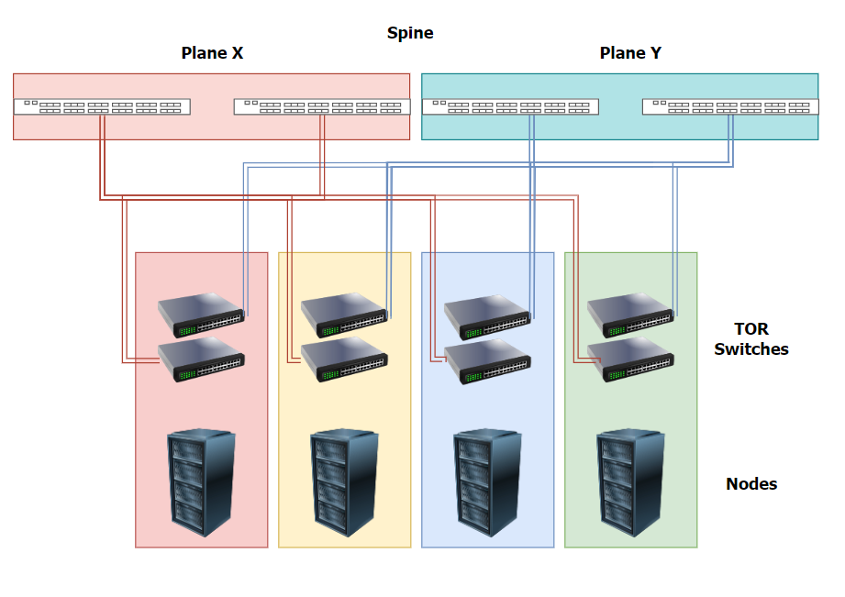
Hardware –

The Diagram represents my HPC AI/ML Data center, inspired by several architectures and designs. It is a 4-pod Data center where each pod (Rack) holds 2 DGX GH200 systems, with a maximum load of 256 Grace Hopper chips connected using NVLink. Each DGX GH200 is connected using 2 NICs to each TOR (leaf) switch, so one DGX has 2 400Gbps ports to each TOR (4 NICs in total to 2 different switches). Thus, each pod has 2 DGX GH200 systems and there is a total of 8 DGX GH200 systems across the entire Data Center

Key Components and Features –
DGX GH200 –
- Each DGX GH200 system contains multiple Grace Hopper chips, leveraging NVLink for inter-chip communication.
- Each DGX system connects to the TOR (leaf) switches via 4 NICs (2 NICs per TOR switch), each providing 400Gbps bandwidth per port ensuring high-speed data transfer and redundancy.
Top of Rack (TOR) / Leaf switches –
- Each pod has 2 TOR (Leaf) switches, one in each of two planes, to enhance redundancy and prevent ECMP (Equal-Cost Multi-Path) related issues, such as Hash Polarization.
- Each DGX connects to 2 different TOR (Leaf) switches, one in each plane for increased redundancy and bandwidth.
Leaf and Spine Architecture –
- The Data center employes a leaf-spine network topology to ensure low-latency and high-bandwidth connectivity.
- Spine switches interconnect all TOR (Leaf) switches in their respective plane providing a robust, scalable and congestion avoidance network.
InfiniBand Interconnect –
- InfiniBand is used for high-performance, low-latency interconnect between switches and DGX systems
- The TOR (Leaf) and spine switches are interconnected with 2 aggregated 1.6TB links providing a total of 3.2TB interconnectivity between each pair.
- TOR (Leaf) switches are Quantom-2 QM 8700 and Spine switches are Quantom-2 QM8800
Overall, each GDX has a connection to each TOR (Leaf) leveraging dual-plane design increasing redundancy further and optimizing network traffic management enhancing overall reliability and efficiency.
Data Preparation –
Since our AI/ML application is a CNN type model and the goal is to identify harmful patterns in cavities and teeth, we will create large datasets containing images and videos exemplifying different abnormalities. These videos and images will teach the model the patterns of unhealthy cavities/teeth or signs of existing medical problems.
We'll collect different types of data from dental clinics, medical databases, and other publicly available datasets. We'll ensure to gather a variety of data that includes a wide range of conditions, angles, lighting conditions, and patient demographics.

We'll process the data and "clean" it, which involves –
- Removing Duplicates – Eliminating any duplicate images and videos to avoid bias.
- Fixing Labeling Issues – Correcting any labeling errors and inconsistencies.
- Handling Missing Data – Addressing any missing or incomplete data.

While there's more to the process of data preparation, it's not the focus of our example. Generally, a data engineer would augment, split, annotate, normalize, and store the data using various methods and techniques, all with the goal of creating a diverse and unbiased dataset to train the model effectively.

Model Development –
After data preparation the next step is developing the model, this involves selecting, training, validating and evaluating the model.
As we mentioned earlier, we decided on a CNN type model due to the nature of the application, common architectures for CNN models include VGG, ResNet, Inception and EfficentNet.
Although we picked a CNN architecture for our application, more advanced applications consist of several types of architectures to allow for more flexibility and versatility.
Another possible alternative is using pre-trained models, these are models which were already trained on datasets, so their Weights & Bias are already set accordingly, using pre-trained models can significantly reduce training time and improve performance, especially if fine-tuned for specific tasks.
The following processes are fetching the datasets and feeding them through the CNN (Neural Network), during this process the model adjusts its parameters to achieve a low Loss Function.
We can validate the accuracy of the model through validation sets and evaluate the performance of the model through test datasets.
The model's development in accordance with these steps will ensure the CNN model is optimized, well-trained and validated for identifying the harmful patterns we look for in our application.

Model Deployment –
This process begins once we have finished training the CNN model and our weights and biases are set accordingly. Our goal now is to deploy the trained model into our existing infrastructure to process new data.
All the hardware decisions we made earlier are now set up and configured (e.g., DGX systems and leaf and spine switches). In this step, we also install and configure any SDN/management software, including operating systems, drivers, libraries, and frameworks (example, Cisco's DNA Center, Cisco ACI, or VMWare NSX).
Next, we'll embed the trained model into our application. This integration allows our customers and testers to use the application as a front-end, sending inputs to our back-end CNN model to generate predictions. At this point, we can also add APIs for external systems to interact with our model.
Additional adjustments or capabilities we can include are –
- Orchestration and Scaling – Implement automated scaling to adjust resources based on demand.
- Containerization – Use containerization (example, Docker, Kubernetes) to ensure consistent deployment across environments.
- Monitoring and Optimization – Continuously monitor performance metrics and optimize resource utilization.
- Security and Compliance – Implement security measures and ensure compliance with relevant regulations.
The final step is to document the entire process and provide training for staff to ensure smooth operation and maintenance.

Questions and answers –
1 – "Evaluate the effectiveness of different high-performance computing (HPC) architectures in supporting advanced artificial intelligence (AI) and machine learning (ML) workloads. Consider factors such as scalability, performance, energy efficiency, and ease of integration with high-performance networking (HPN) and high-performance storage (HPS) solutions."

When evaluating the effectiveness of different HPC architectures in AI/ML workloads we must consider the following factors in accordance with our goals and application –
Beowulf Clusters – architecture that consists of a collection of standalone computers (nodes) interconnected via a shared LAN to work together on parallel processing tasks, each node runs its own operating system and is responsible for executing part of the overall computational task.
This architecture is easy to manage and scale, it allows for solid general performance and energy efficiency and ease of integration, the main drawback of this system is the mediocracy of it, it is an all-around good pick yet lacks the optimization and flexibility other architectures allow.

Distributed Computing – there are several methods to achieve architectures such as MapReduce or Apache Spark, this architecture allows for optimized distribution of processing across different machines. Hadoop is widely used implementation of this architecture for storage solution.
This architecture can be more complex, but it prioritizes scaling and parallel computing efficiency and speed, the distribution of nodes allows for more flexibility.
On larger scales it is also referred to as MPP (Massively Parallel Processing), Cuda's architecture created by Nvidia allows for thousands of GPUs to parallel compute in unison utilizing NVLink and RDMA
Other options include Cloud-based solutions such as AWS EC2 P3 Instances or Google Cloud AI Platform.
All these solutions need to be carefully considered with the application's goal in mind, the performance goal and the budget.

For example's sake, an expensive budget which only cares for performance and latency and achieving the fastest AI/ML workload completion time can use the Distributed Computing architecture that can be more complex and costly but allows for high bandwidth, low latency and efficiency.
On the other hand, a low budget organization can offload workloads to Cloud based solutions such as Amazon's AWS, this allows them to save costs by compromising the task completion time.

2 – Analyze how the integration of high-performance networking (HPN) technologies, such as NVLink and RDMA, influences the performance and efficiency of HPC architectures in executing AI/ML workloads. What are the specific benefits and challenges associated with these technologies?

When analyzing the integration of HPN technologies such as NVLink and RDMA can provide several direct benefits to the HPC environment and the workload completion speed.
NVLink – Bus protocol technology which allows greater throughput for GPUs, this technology (Nvidia proprietary) improves the existing Bus PCI interface which ultimately enables faster data transfer between GPUs and other devices.
RDMA – a communication protocol that allows GPU-to-GPU direct data transfer and memory access, this protocol is particularly useful in parallel processing.
GPUDirect – RDMA over Nvidia's GPUs, a Nvidia proprietary protocol which is optimized for Nvidia's GPU suite.
These technologies can significantly improve overall performance which makes them integral for HPC environments.
There are some downsides to them, when opting for Nvidia's specific GPUs and NVLink with GPUDirect you become vendor locked which could impact budget, they also add complexion to the network and require further knowledge to use correctly.
Both RDMA (And GPUDirect) and NVLink are integral for AI workloads.

3 – Evaluate the trade-offs between using proprietary technologies such as Nvidia's NVLink and GPUDirect versus open standards like RDMA for high-performance AI/ML workloads. Consider aspects such as performance, cost, vendor lock-in, and ease of integration.
When considering opting into proprietary technologies it is important to weight the advantages versus the disadvantages.
GPUDirect and NVLink are Nvidia proprietary protocols optimized for Nvidia's GPU & CPU suite, they provide increased throughput, lower latency, better redundancy and overall system improvement.
When purchasing Nvidia's equipment it's crucial to understand the drawbacks of vendor locking versus the advantages, while open standards allow for flexibility and are considerably cheaper, they are usually not as optimized as proprietary solutions.

4 –
4 – Discuss the impact of emerging technologies like Quantum Computing and Photonic Computing on the future of AI/ML workloads. How might these technologies address current limitations in classical computing architectures, and what are the potential challenges in adopting them?
when discussing the impact of emerging technologies such as Quantum Computing on the future of AI/ML workloads it's important to understand the advantages and disadvantages of Quantum Computing and their integration process.
Quantum Computing impacts AI/ML workloads through quantum mechanics, the capabilities are utilized through various techniques that are significantly different from traditional computing.
- Quantum Speedup – Quantum computers use Qubits that can represent and process more information compared to bits. This allows quantum computers to solve certain problems much faster and efficiently.
  - This results in faster Training time for models.
  - Efficient optimization of algorithms.
- Quantum algorithms – Quantum computing introduce several algorithms based on quantum mechanics concepts.
  - Grover's Algorithm – speeds up operations.
  - Quantum Fourier Transform – used in algorithms for factoring large numbers which can impact cryptographic systems used in secure ML.
  - Quantum Approximate Optimization Algorithms (QAOA) – can solve complex optimization problems found in ML more efficiently compared to traditional algorithms.
- High Dimensional Data Processing – Quantum computers can inherently handle high-dimensional spaces which are more common in ML.
All these capabilities and more can significantly impact HPC AI/ML workloads and model training & inference, several challenges can emerge from integration and practical use-cases for Quantum mechanics.
Among these limitations are Hardware limitations due to lack of research, algorithms development which hasn’t reached practicality and costly R&D.
Although Quantum computing is still an emerging technology that isn't optimized, yet it shows a future that's worth noting for improvement of HPC environments.

5 – Examine the implications of using Federated Learning (FL) in conjunction with edge computing for privacy-preserving AI/ML workloads. Discuss how this approach can address data privacy concerns, improve latency, and enhance scalability, while considering the technical challenges and potential limitations in the deployment of such systems.
When examining the implications of FL and Edge computing with the goal of privacy in AI/ML workloads we need to understand what FL is and how to work properly with it in an AI/ML environment.
Federated Learning (FL) is a distributed approach where each node holds its own training data and independently trains the model. The nodes then send the model updates (parameters) to a central server for aggregation. This process repeats in cycles, enhancing privacy as data remains local.
Federated Learning has several advantages over traditional distributed computing, and it largely revolves around security, because each node holds their own dataset, they're able to fetch data much faster compared to centralized storage system. This method is inherently more secure too because data isn't moving across the network. In this method the updates being sent to the main server can also undergo encryption to secure the model parameters and avoid model theft. Federated Learning being a distributed system is also benefited by easy scalability
Although it has benefits it does introduce several issues, some are inherent in Distributed systems, and some are inherent to Federated Learning.
Budget – This issue exists in Distributed processing but largely surges due to Federated Learning, Federated learning introduces not only the need for redundancy and bandwidth but also storage capacity and retravel which substantially increases the price of each node.
Complexity – Distributed processing introduces new complexity to the network but adding onto it per node storage and encryption could increase this further.
Latency – this issue is inherent to distributed processing but could be further highlighted due to the encryption security requirements, latency is primarily caused due to geographical distance and asynchronous processing and slaggers.
Federated Learning, when combined with edge computing, offers significant advantages for privacy-preserving AI/ML workloads. While it introduces challenges such as increased costs, complexity, and potential latency, these can be managed with proper planning and technology. This makes FL a viable option for organizations prioritizing data security and efficient, scalable model training.

